**Advance Excel Assignment 4**

1. To use the ribbon commands, what menu and grouping of commands will you find the Insert and Delete command?

**Solution:**

We can find the Insert and Delete command in the Cells section under the Home Menu bar

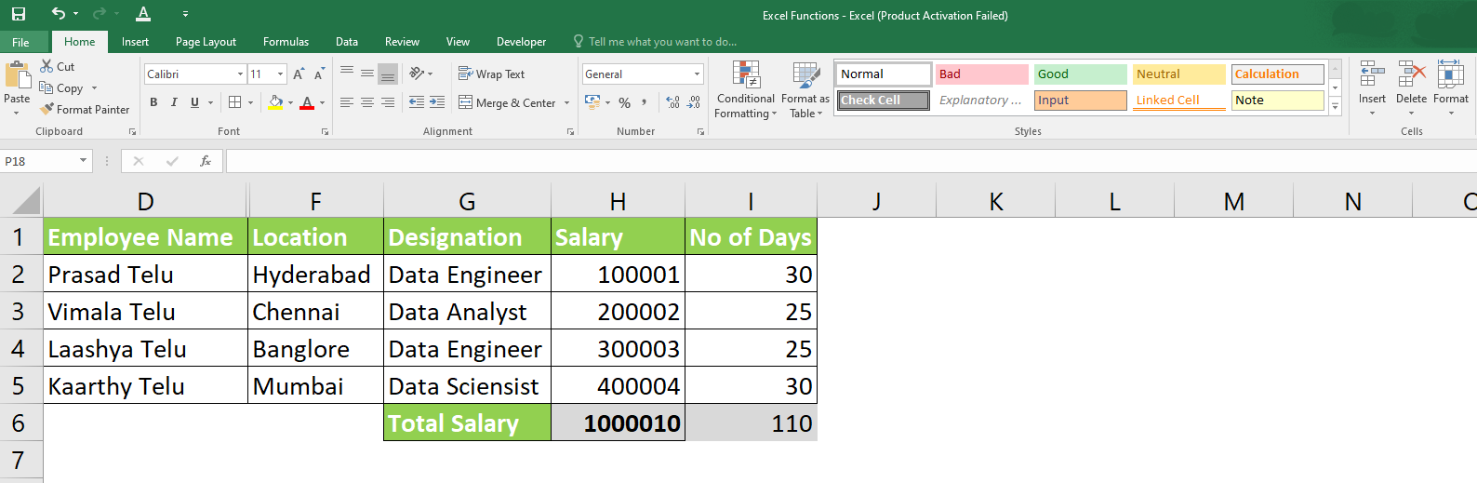

1. If you set a row height or column width to 0 (zero), what happens to the row and column?

**Solution:** Both Column and Rows are hidden when set the column with is Zero or row height is Zero

**Set column width: 0**

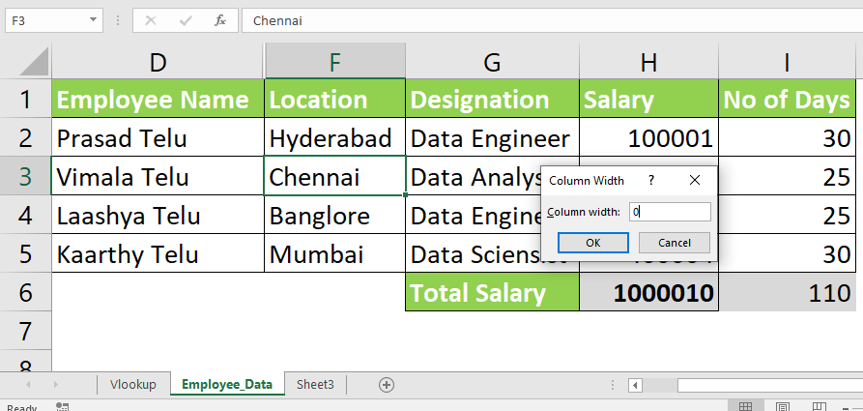

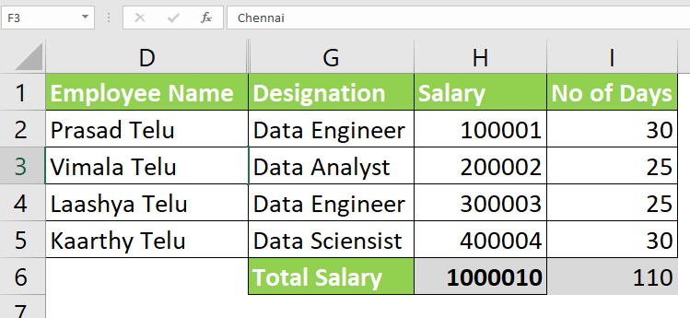

**Set row height: 0**

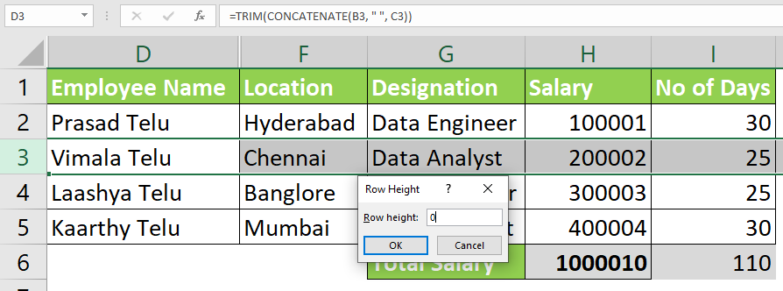

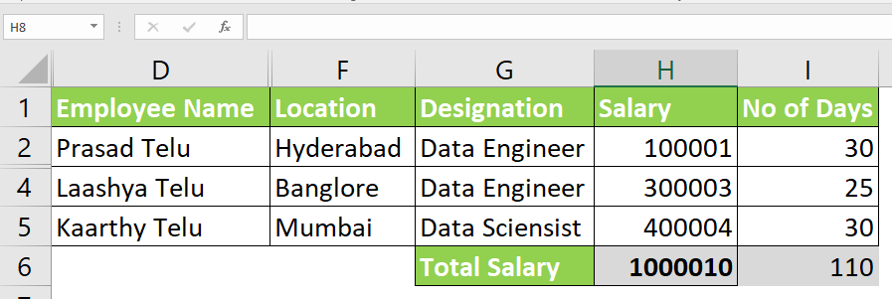

1. Is there a need to change the height and width in a cell? Why?

**Solution:**

In Excel, by default, the width and height of the cell are defined as 8.43 and 15 inches, however, when the data is exceeding the defined width /height, the user has the feasibility to change the dimensions according to the data to represent in look and feel. The screenshot below for reference.

Default sizes of the Width and Height in Inches

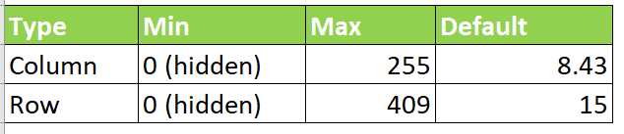

Column width is adjusted as per the data appears in cell also look and feel.

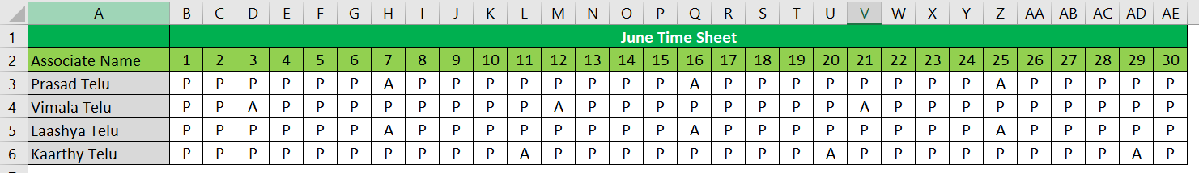

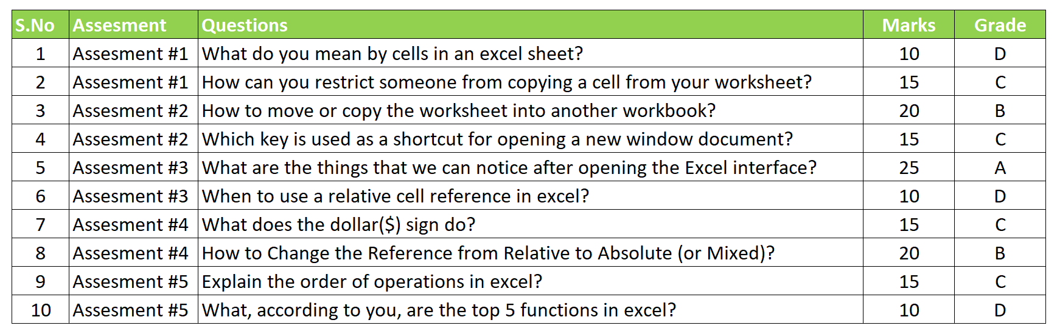

1. What is the keyboard shortcut to unhide rows?

**Solution:**

Shortcut to unhide rows in Excel= **Ctrl+Shift+(**

1. How to hide rows containing blank cells?

**Solution:** To hide the rows which containing blank cells, select “**Go To Special**” option.

* Select the data range which contains the blank cells you want to hide.

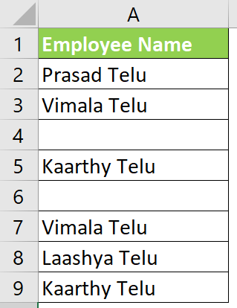

* Then click Home > Find & Select > Go To Special

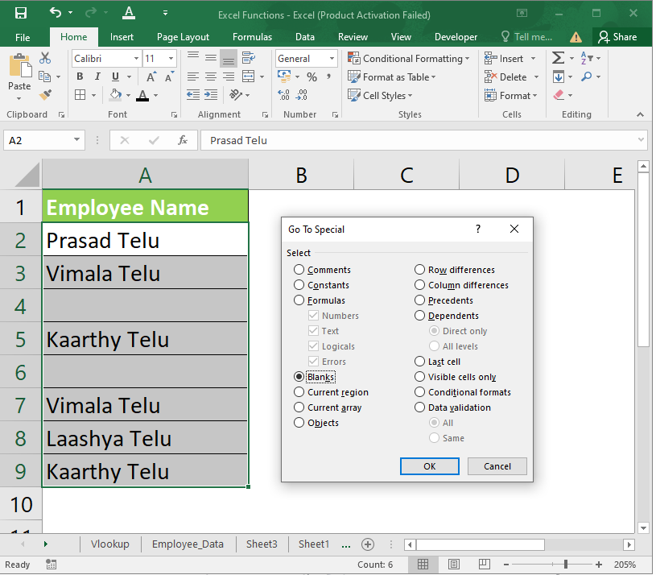

* And in the Go To Special dialog, select the Blanks option, and then click the OK button.
* All of the blank cells in the selection would have been selected
* Then you can press Ctrl + 9 keys together to hide the rows which have blank cells.

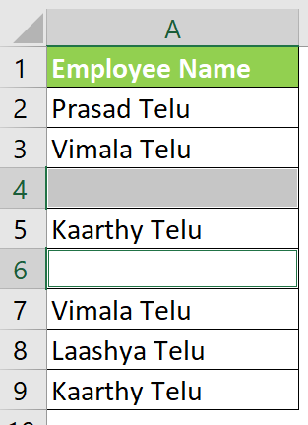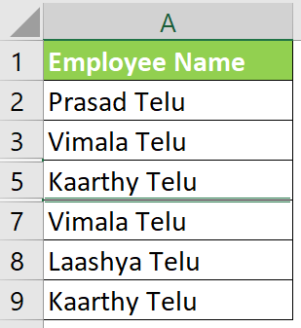

1. What are the steps to hide the duplicate values using conditional formatting in excel?

**Solution:**

1. Select range A2:A7

2. On the Ribbon's Home tab, click the Conditional Formatting button, then click New Rule

3. Click Use a Formula to Determine Which Cells to Format and choose Format|Conditional Formatting

4. In the formula, enter =A3=A2

5. Click the Format button.

6. Select a font colour to match the cell colour.

7. Click OK, click OK

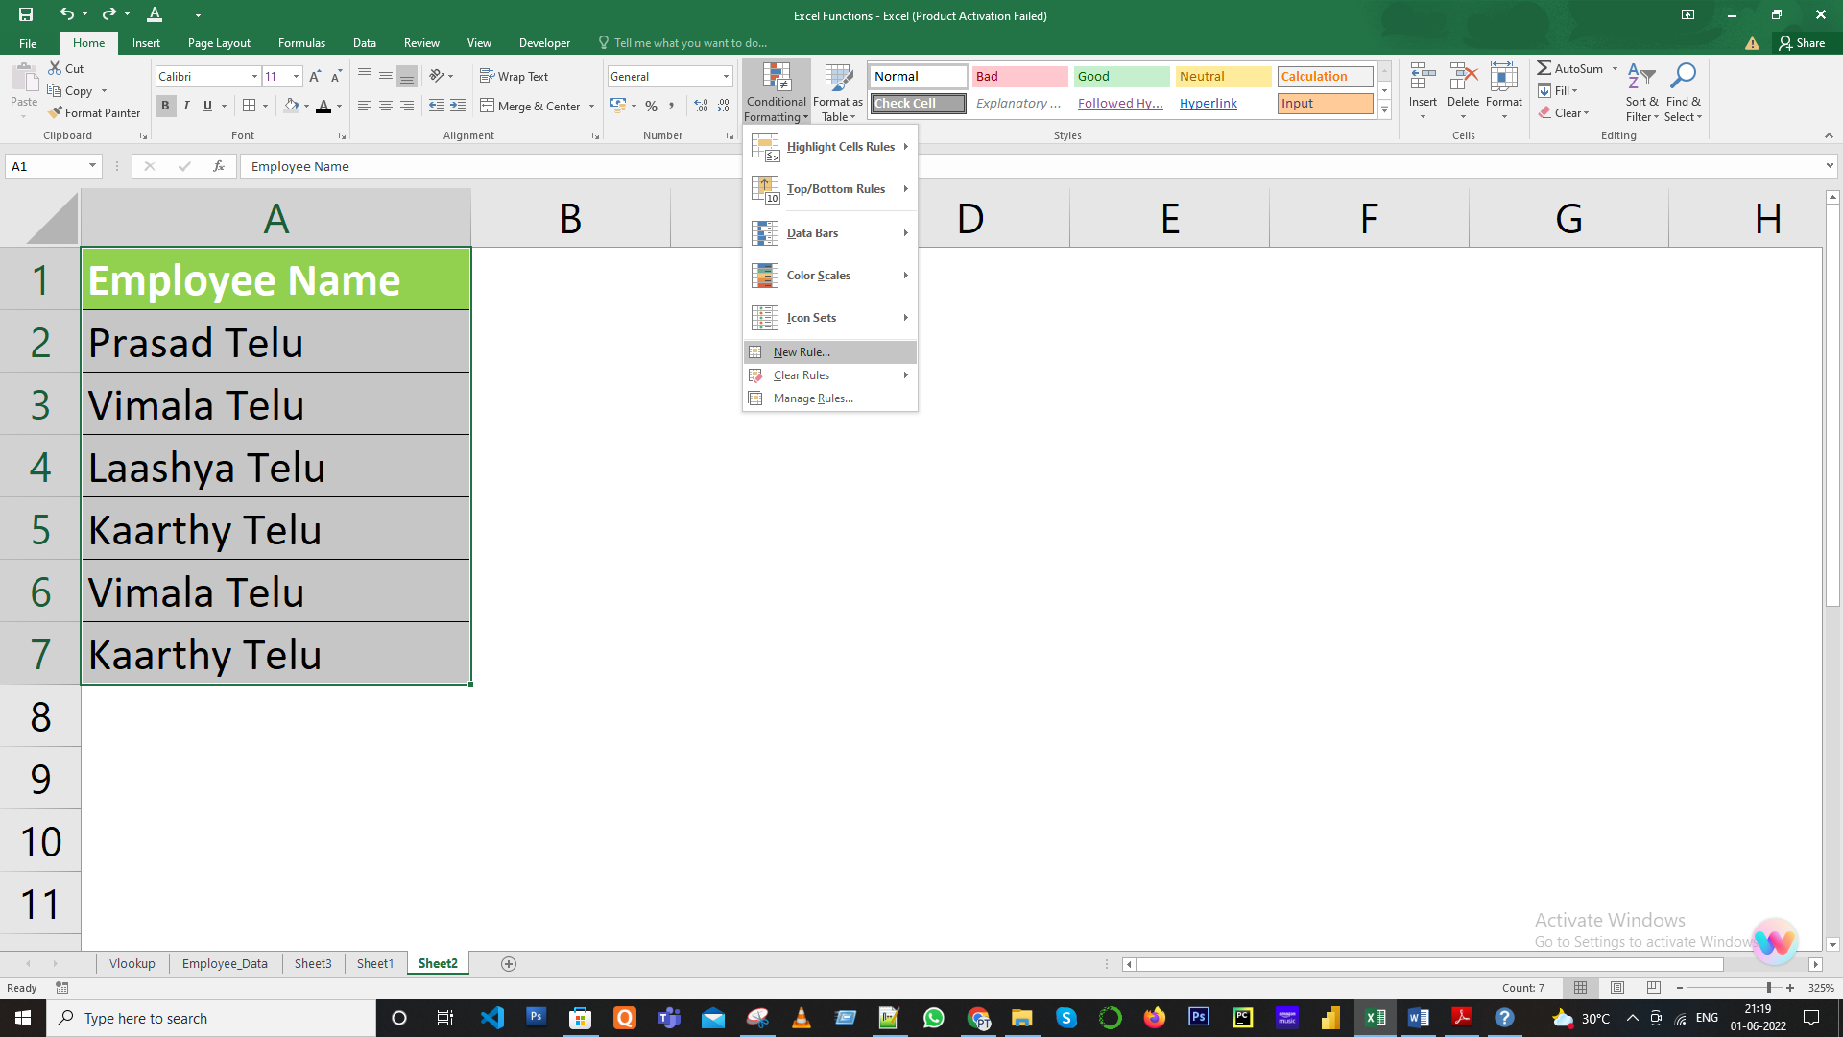

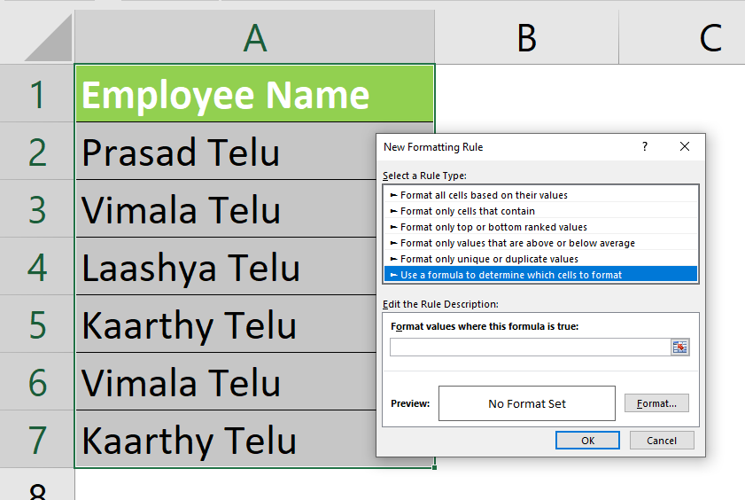

Click Ok

